**Upload New Version of File - SP Doc**

**Summary:**

* Updates New Version of File in SharePoint Document Library

**Development Steps:**

Add action as “Get files”

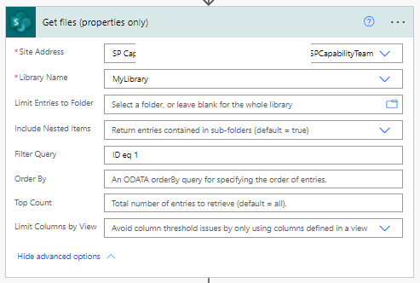

Add “Get File Metada”

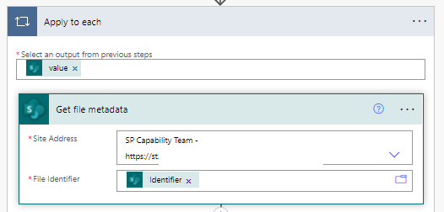

Now you need to convert the file to base64. Google for online conversion and get base64 code

Add 2 “Compose” actions as

For First Compose, paste all base64 code generated earlier.

Add action of “Update File”

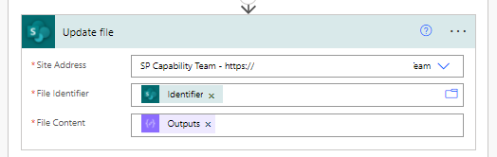

After you run the flow, you can see new version file is loaded successfully.

